
Science Understanding (U)
This strand addresses ’what’ we know when teaching and learning about a topic in Science. It includes the foundational concepts, theories and explanatory
models – including models of systems and interactions – that form the basis of biology, chemistry, Earth and space sciences, and physics.

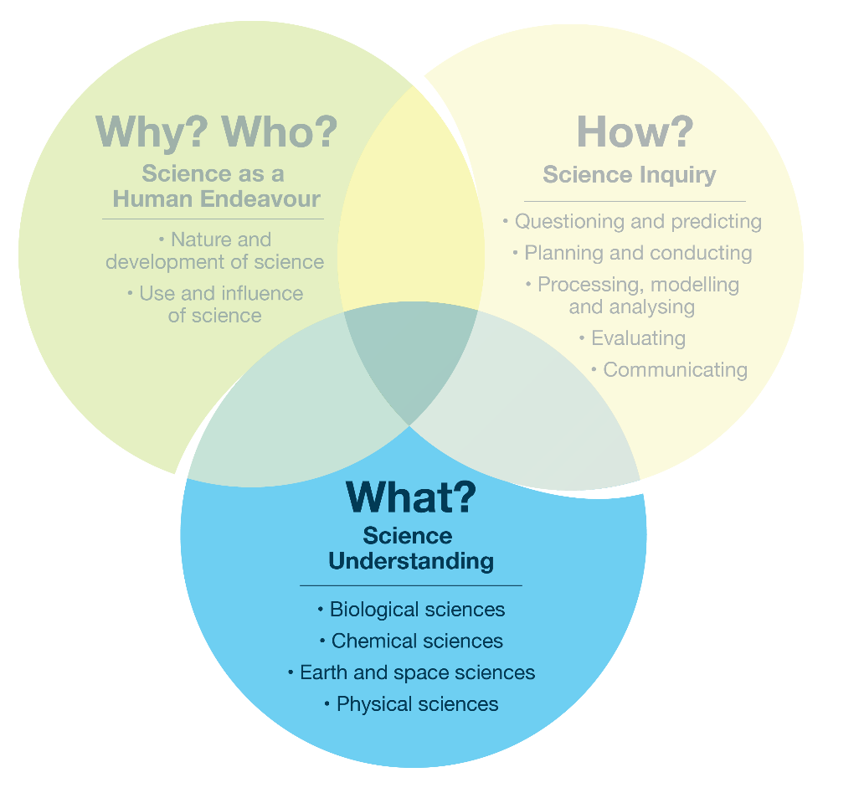
Focus 1.2 – The Science Understanding strand and sub-strands

Example topic – single strand
Students might be prompted to explain Newton’s ideas about gravity and describe the attraction between objects.
Possible focus questions | Curriculum alignment
What scientific idea about gravity did Newton develop after observing falling objects? | Physical sciences: gravity as a force of attraction between masses
What would happen to people, objects and oceans if Earth’s gravity became stronger or weaker? | Physical sciences: effects of gravity on motion and stability
Why is gravity weaker on the Moon than on Earth? | Earth and space sciences: gravity differences between celestial bodies

